OUTPUT

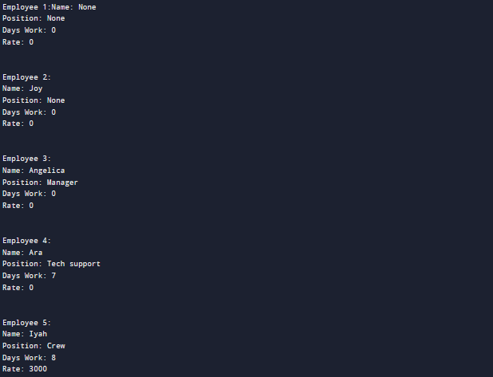

SOURCE CODE

//author: Emblawa, Joshua

//date: March 11, 2023

// overloaded structure

public class EmblawaEmployee {

String name;

String position;

int dayswork;

int rate;

//Default Constructor

public EmblawaEmployee(){

this.name = "None";

this.position = "None";

this.dayswork = 0;

this.rate = 0;

}

//Overloaded constructor

public EmblawaEmployee(String name){

this.name = name;

this.position = "None";

this.dayswork = 0;

this.rate = 0;

}

//Overloaded constructor

public EmblawaEmployee(String name, String position){

this.name = name;

this.position = position;

this.dayswork = 0;

this.rate = 0;

}

//Overloaded constructor

public EmblawaEmployee(String name, String position, int dayswork){

this.name = name;

this.position = position;

this.dayswork = dayswork;

this.rate = 0;

}

//Overloaded constructor

public EmblawaEmployee(String name, String position, int dayswork, int rate){

this.name = name;

this.position = position;

this.dayswork = dayswork;

this.rate = rate;

}

//Getter

public String getName(){

return name;

}

public String getPosition(){

return position;

}

public int getDayswork(){

return dayswork;

}

public int getRate(){

return rate;

}

public static void main(String[] args) {

EmblawaEmployee emp1 = new EmblawaEmployee();

EmblawaEmployee emp2 = new EmblawaEmployee("Joy");

EmblawaEmployee emp3 = new EmblawaEmployee("Angelica", "Manager");

EmblawaEmployee emp4 = new EmblawaEmployee("Ara", "Tech support", 7);

EmblawaEmployee emp5 = new EmblawaEmployee("Iyah", "Crew", 8, 3000);

// Print

System.out.println("Employee 1:");

System.out.println("Name: " + emp1.getName());

System.out.println("Position: " + emp1.getPosition());

System.out.println("Days Work: " + emp1.getDayswork());

System.out.println("Rate: " + emp1.getRate()+"\n\n");

System.out.println("Employee 2:");

System.out.println("Name: " + emp2.getName());

System.out.println("Position: " + emp2.getPosition());

System.out.println("Days Work: " + emp2.getDayswork());

System.out.println("Rate: " + emp2.getRate()+"\n\n");

System.out.println("Employee 3:");

System.out.println("Name: " + emp3.getName());

System.out.println("Position: " + emp3.getPosition());

System.out.println("Days Work: " + emp3.getDayswork());

System.out.println("Rate: " + emp3.getRate()+"\n\n");

System.out.println("Employee 4:");

System.out.println("Name: " + emp4.getName());

System.out.println("Position: " + emp4.getPosition());

System.out.println("Days Work: " + emp4.getDayswork());

System.out.println("Rate: " + emp4.getRate()+"\n\n");

System.out.println("Employee 5:");

System.out.println("Name: " + emp5.getName());

System.out.println("Position: " + emp5.getPosition());

System.out.println("Days Work: " + emp5.getDayswork());

System.out.println("Rate: " + emp5.getRate()+"\n\n");

}

}